Canadians invited to Step up to the plate and work in ag jobs
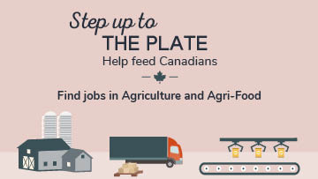
Each year, more than 15,000 jobs in agriculture and food production remain vacant. The COVID-19 pandemic has added to the challenge of filling these essential positions.
The Step up to the plate employment portal invites Canadians to take another look at working in agriculture and agri-food.
Jobs in agriculture and food production are diverse, rewarding and leverage many different skill sets. They contribute to growing, transforming, packaging, and delivering food products that communities across Canada count on every day.
Now is the time to take advantage of the many employment opportunities available in the ag sector.
The portal raises awareness about job resources in agricultural and food industries, and helps connect job seekers to vacant positions posted on independent job websites. It links to more than 25 separate national and regional job sites across the country, each with their own criteria and application processes for jobs on farms, in distribution, food processing, and in other related occupations.
It also provides health and safety, as well as skills and training resources for workers.
If you're an agriculture or agri-food employer, don't forget to make sure your vacant positions are posted on one of the independent job sites linked from the Step up to the plate portal.

